**Azure Synapse Analytics**

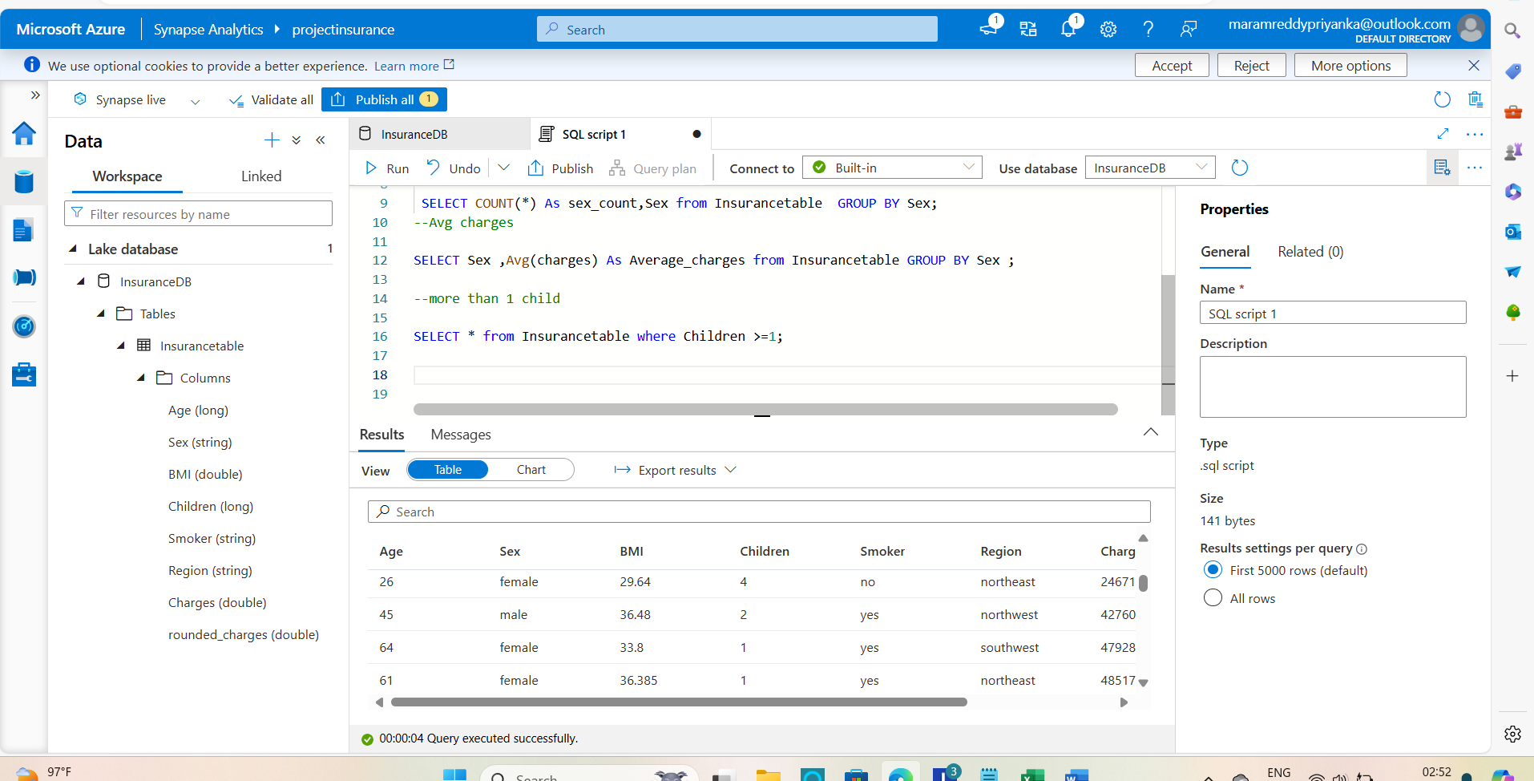

 -- people whose BMI is more than 30

 Select * from Insurancetable where BMI >30;

 --Count of female and male

 SELECT COUNT(*) As sex_count,Sex from Insurancetable  GROUP BY Sex;

--Avg charges

SELECT Sex ,Avg(charges) As Average_charges from Insurancetable GROUP BY Sex ;

--more than 1 child

SELECT * from Insurancetable where Children >=1;

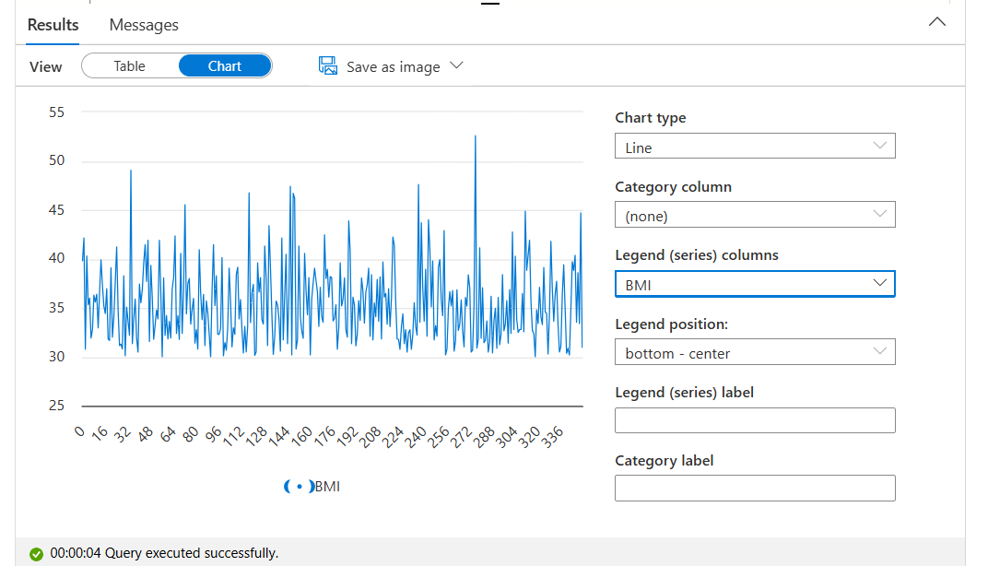

Line Chart for BMI more than 30

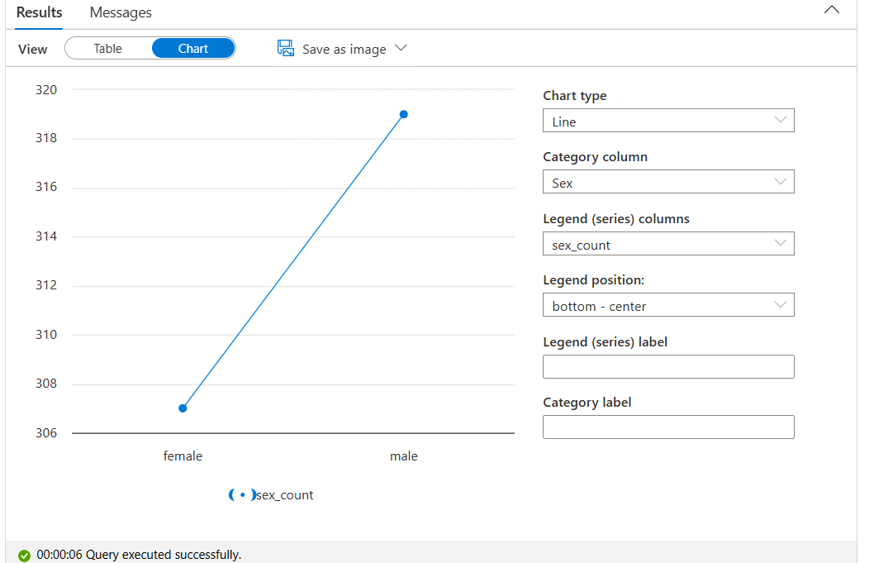

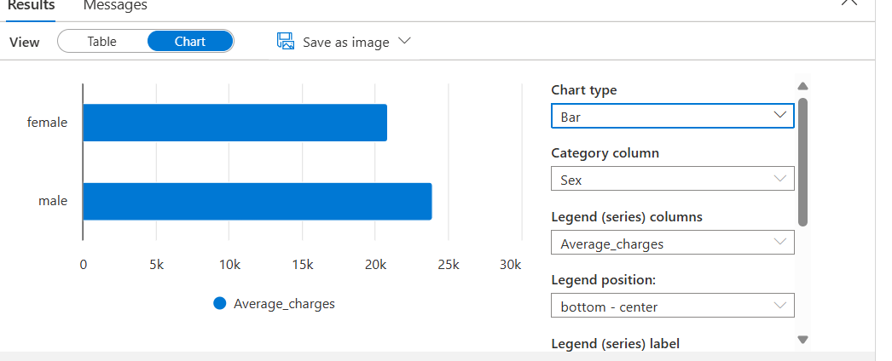

Average charges per Sex

